

65

CAFE



BEST PLACE FOR PARTIES BIRTHDAY,LAUGHTER ,TASTE & SURPRISES

ITALIAN / BEVERAGES / DESSERT/
/SOUTH-INDIAN / SNACKS/ MILK SHAKES...



YOUR WISH OUR DISH...

CAFE 65

Coffee

Hot BreW
Hot Coffee Filter Coffee Espresso Americano
e Hot chocolate
Hazelnut Hot chocolate

Cold Coffee

110/-
110/-
169/-
169/-
199/-
249/-

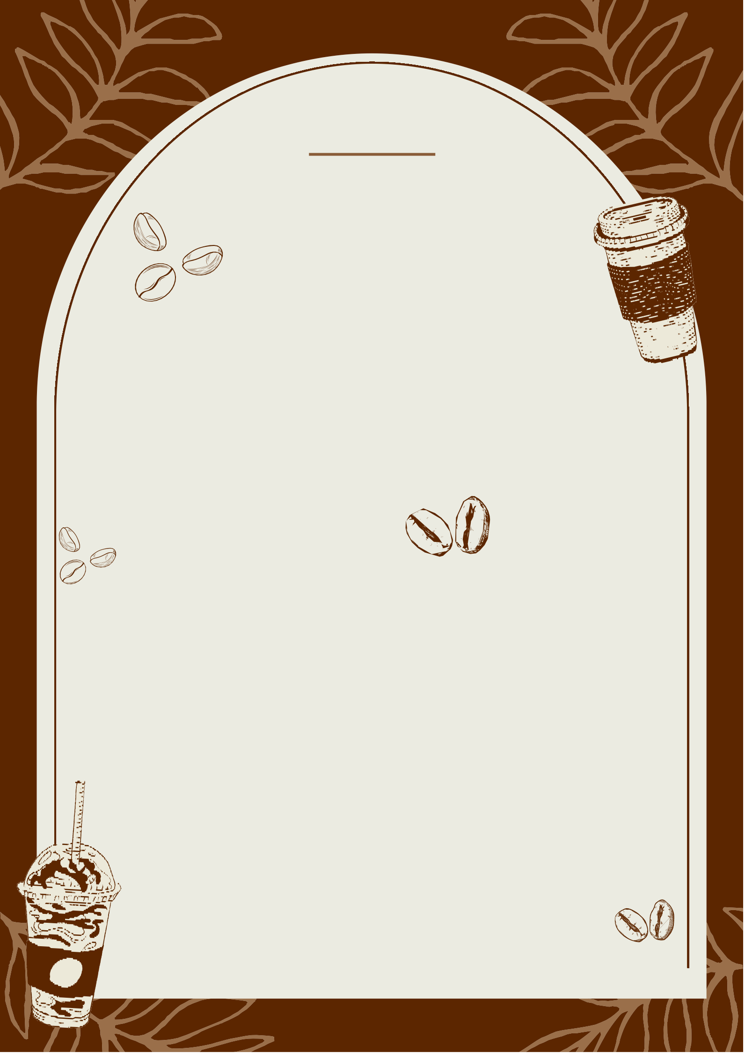
Classic Cold Coffee
Cold Coffee with Ice-cream Hazelnut Cold Coffee
Irish Cold Coffee
150/-
180/-
220/-
220/-

Bread Butter
CAFE 65

ToaSt & BreadS

80/-


(3 slice of bread cut into 2 piece)
Jam Bread
(3 slice of bread cut into 2 piece)
Kadak Toast Garlic Bread
Cheese Garlic Bread Cheese Chilli Garlic Bread

Tea & MaSka
Chai Green Tea
Ginger Tea
Amul butter toast Maska Bun
90/-
60/-
150/-
190/-
210/-

40/-
50/-
50/-
80/-
90/-

CAFE 65

PIZZA

INCH “8"/”10"/”12"

Margherita Pizza | 179/249/360
(Margherita sauce and cheese baked at a perfect tempreature for
the best crust and cheese pull)
Onion,Corn & Cheese Pizza | 189/280/370
(Baked with corn and heavy cheese layer)
Capsicum & Onion Pizza  (capsicum & onion layer baked with mozzarella cheese) | 189/270/390
FarmHouse Pizza  (Pizza loaded with capsicum,mushroom,oilves,Jalapenos,onion and | 189/290/430
Exotic Vegetable with cheese)
Spicy Paneer Pizza  (Spicy Paneer with vegetables and cheese) | 189/290/390
Mushroom & Veggie Pizza  (Mushroom & Vegetables and cheese ) | 189/290/390
Paneer Makhani Pizza  (Makhani sauce toosed in panner with vegetables and cheese) | 199/290/430

ADD-ON
Cheese Burst--
“8"/”10"/”12" 50/80/110

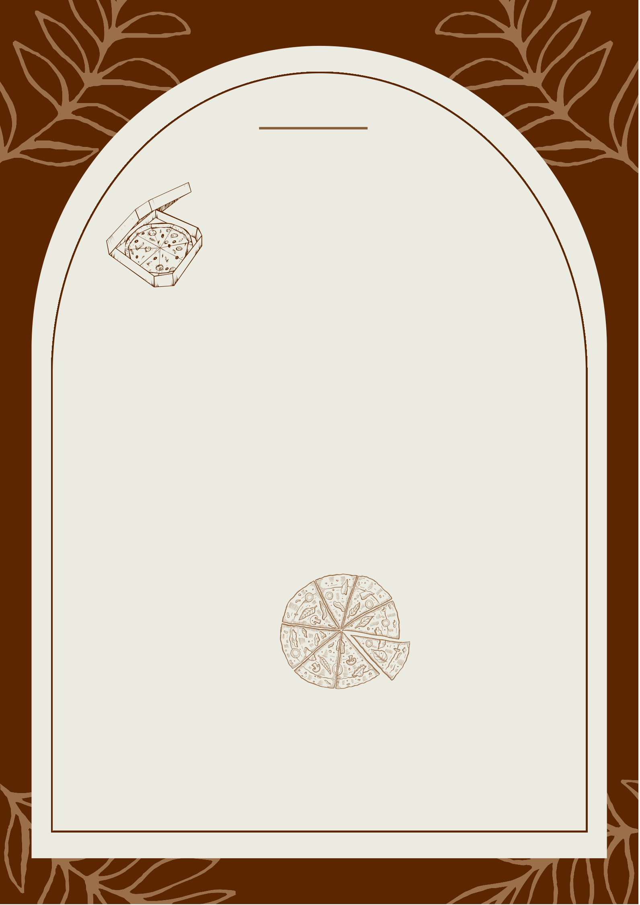
Extra Veggie (Per Veggie)--30/-

Onion Rings
CAFE 65

SMALL BITES

199/-


Potato Wedges Veggiee sticks
Corn & Cheese Balls Nachos
MAGGI
Plain Maggi Peri Peri Maggi Cheese Maggi
Peri Peri Cheese Maggi
249/-
199/-
199/-
199/-

99/-
119/-
149/-
189/-

CAFE 65

PASTA


Alfredo Pasta
(Tossed In white Creamy Sauce With Exotic Veggies)

Baked white Sauce Pasta
(Mix of White Cream Sauce, tossed with Exotic Veggies)

Macroni Cheese Pasta
(Full load of cheese heaven with lot of cheesey Creamy pasta)

Desi Swaad Pasta
(A indian Spiced Pasta With Desi taste)

Choice Of Pasta
Pennee Fusilli Macroni
280/-

330/-

349/-

299/-

CAFE 65

BURGER

Experience the taste between the Bun

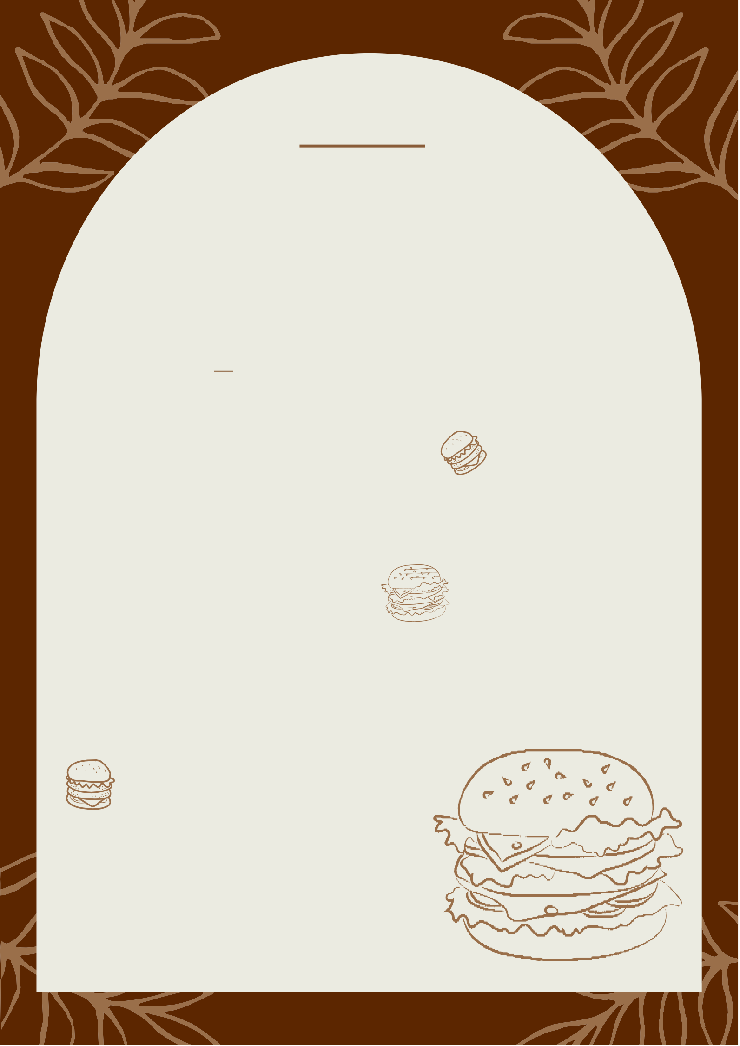

Aloo Tikki Burger Biggy Veggie Burger Crispy Panner Burger Creamy Cheese Burger

MahaRaja Burger

Spicy Peri Peri Mexican Burger
99/-

149/-

179/-

179/-

269/-

249/-

CAFE 65

SANDWICH

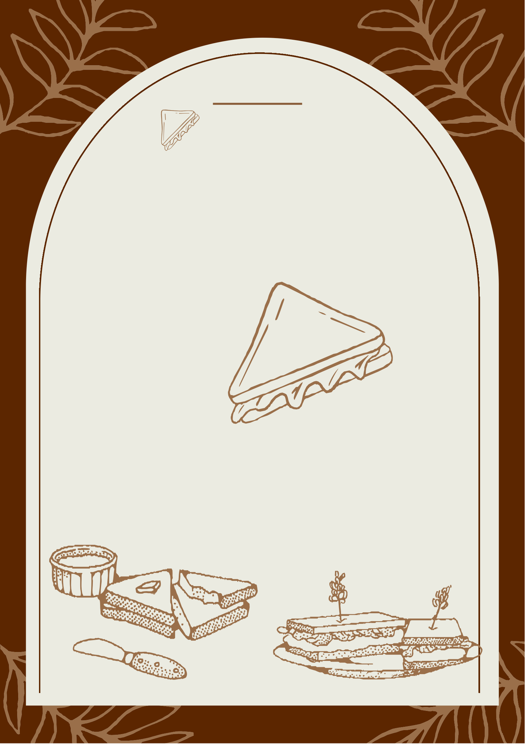
Club Sandwich Chocolate Sandwich
Cheese GRILLED Sandwich Vegetable cheese Sandwich Paneer Grilled Sandwich
Paneer Makhani Grilled Sandwich Bombay Sandwich
129/-

129/-

149/-

179/-

199/-

199/-

169/-

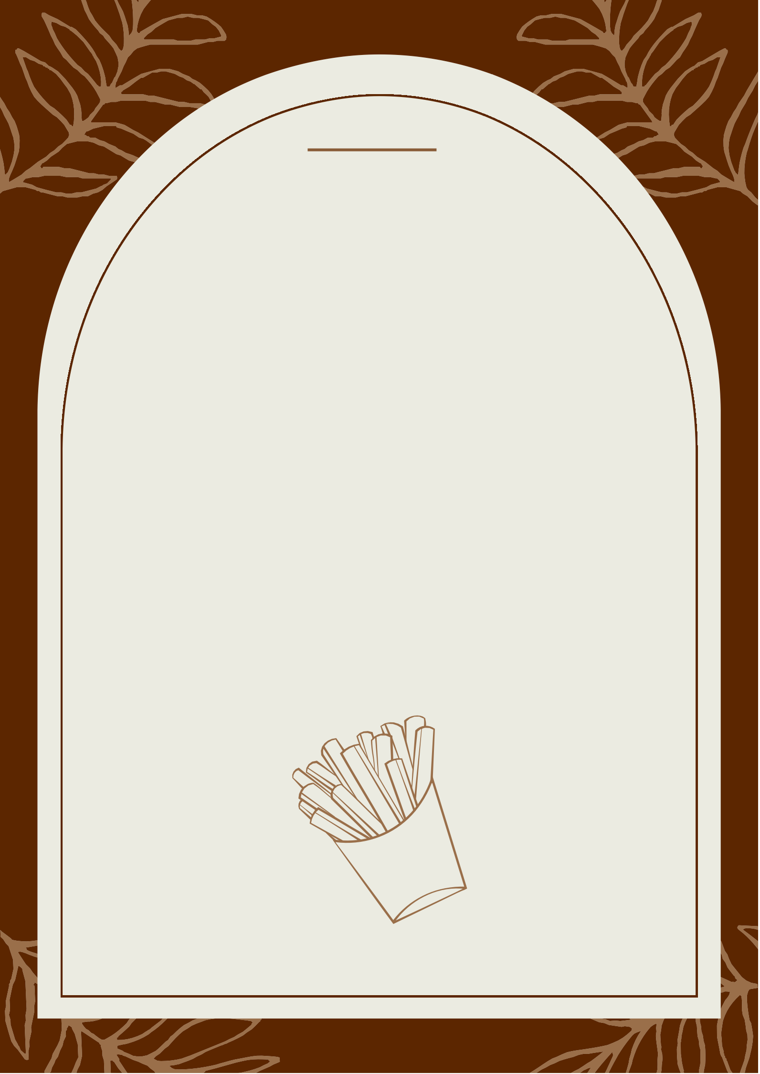
CAFE 65

FRIES

Salted crispy Fries  (The First fries you had in your mind) |  | 149/-
Peri Peri Fries  (Tossed and Mixed in Spicy and surprise Masala) |  | 190/-
Cheese loaded Fries  (Cheese cheese And cheese till it satisfy your cravings | ) | 220/-
Mexican Loaded Fries |  | 220/-
(Fires Loaded with, mayo,Spice of peri peri ,sauce, and exotic taste)

(Dips) Mayo Cheese Greek Dip Spicy Dip

30 Extra for the choice of dips

CAFE 65

MILKSHAKES


Vanilla Shake
(Smooth & creamy concoction of vanilla ice cream, milk & vanilla extract)

Strawberry Shake
(A blend of strawberry shot syrup)

Chocolate Shake
(Old fashioned milkshake made with thick & indulgent chocolate & chocolate ice cream)
Cold Bournvita 🌟
(Nostalgic chocolate milk)

Kit-kat Milkshake
(blend of kit-kat and choclate )

Oreo Milkshake
(Creamy & chocolatey balance)

Dry Fruit Milkshake
(Blend of all the healthy dry fruits )

Browine Shake
(Loaded with brownie & chocolate)
Blueberry Shake 🌟
(Prepared with blueberry & vanilla taste fruity & creamy)

Mango Milkshake
(Blend of alphonso mango & Milk)

Nutella & Brownie Shake
(Blend of nutella , hazelnut & cocoa)
Lotus Biscoff Shake 🌟
(Blend of creamy biscoff spread, crunchy biscoff cookies & vanilla)
ADD ICE CREAM TO YOUR SHAKE: | 60
Blueberry l Vanilla | Chocolate | Strawberry
130/-

130/-

149/-

149/-

180/-

180/-

160/-

220/-

230/-

149/-

250/-

280/-

200/-

CAFE 65

Iced Coffee

Iced Americano Iced Latte
189/-
199/-

Iced Mocha | 199/-
Iced Vanilla Latte | 220/-
Classic Cold Brew | 180/-


